Bybee Passive Room Neutralizers

The Bybee Room Neutralizers offer a unique and revolutionary way of effectively removing the acoustic limitations of the listening environment while presenting the listener with a holographic surround effect. The Bybee Room Neutralizers use a proprietary blend of materials and technology that resonate with the air molecules in the listening area, enabling the transmission of sound without the usual time misalignment of high frequencies. As a result, sonic purity and beauty become striking as all the wall reflection grunge remarkably disappears in an audio system that no longer has to fight room acoustics to make its musical statement.

These units work well with other room treatments such as the Stein Music Harmonizers, Shakti Hollographs, and Stillpoints Apertures.

Each unit is 2 inches wide, by 6 inches long, by ¼ inch thick, with a 6-inch antenna tail. A set of 8 units will be effective for room areas of up to 650 square feet. Larger rooms may require additional units.

Uses – Homes, Automobiles, Studios, and any other area used for music and sound enjoyment.

Placement – Every listening environment is different in acoustics, therefore optimum placement of the units will very slightly from area to area. Consequently, experimenting with the placements of the units is encouraged to achieve the best results. The following are general rules for the placement of a complete set of 8 units:
- The Room Neutralizer antenna can be positioned in any direction
- Units can be placed with either side next to the wall
- Room Neutralizers are designed to be placed discretely behind objects, and if so placed, the antenna should be exposed just slightly
- Units should be positioned on wall at a height of 3 to 5 feet from the floor. However, placements at higher or lower heights will also achieve good results. Experimentation is key for your best results.
- At a minimum, one unit should be placed near each corner of the listening environment. Placement in the corners can be either on the sidewall or front/back wall.
- One unit should be placed on each sidewall at approximately equal distance between corner units.
- One unit should be placed on the rear of each speaker, at a location closest to the top of the speaker
- It is recommended that the units be initially attached with a non marking (blue painter’s) tape or similar product for experimental purposes. Once the optimum locations are determined, the units can be attached to the wall, rear of picture, or other wall ornament with the included adhesive tape.

Other Information – The Bybee Room Neutralizers can be painted if desired. If used in an automobile, it is recommended to use two Neutralizers in the front area and two units in the rear seat area of the automobile. They can be placed discretely in locations with the antenna slightly exposed.

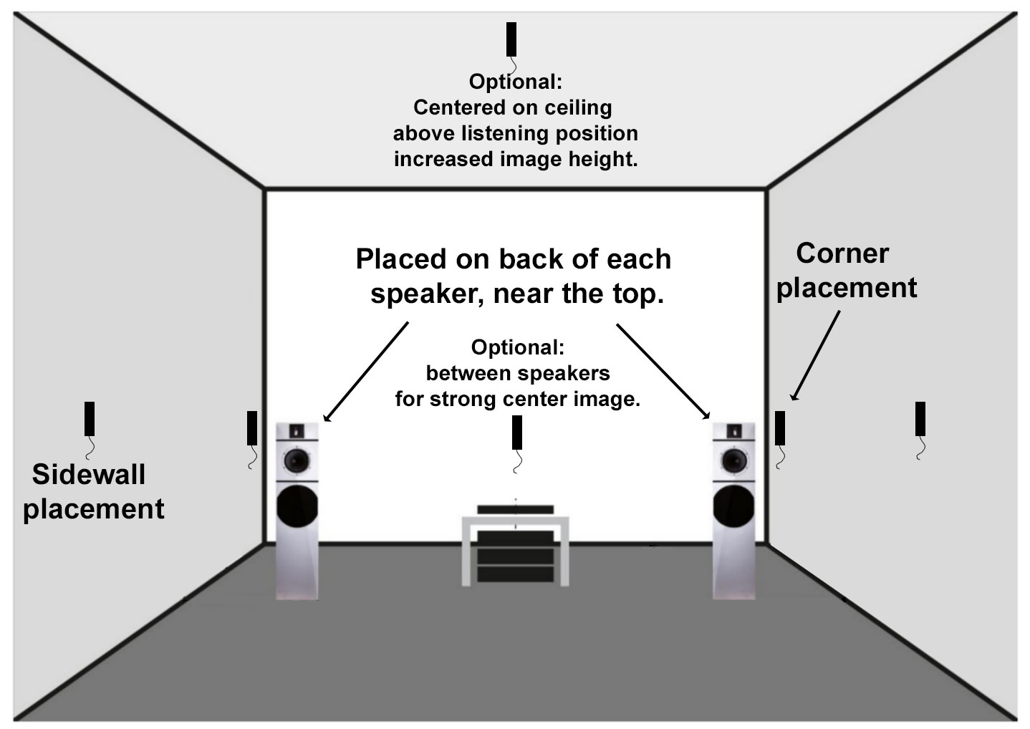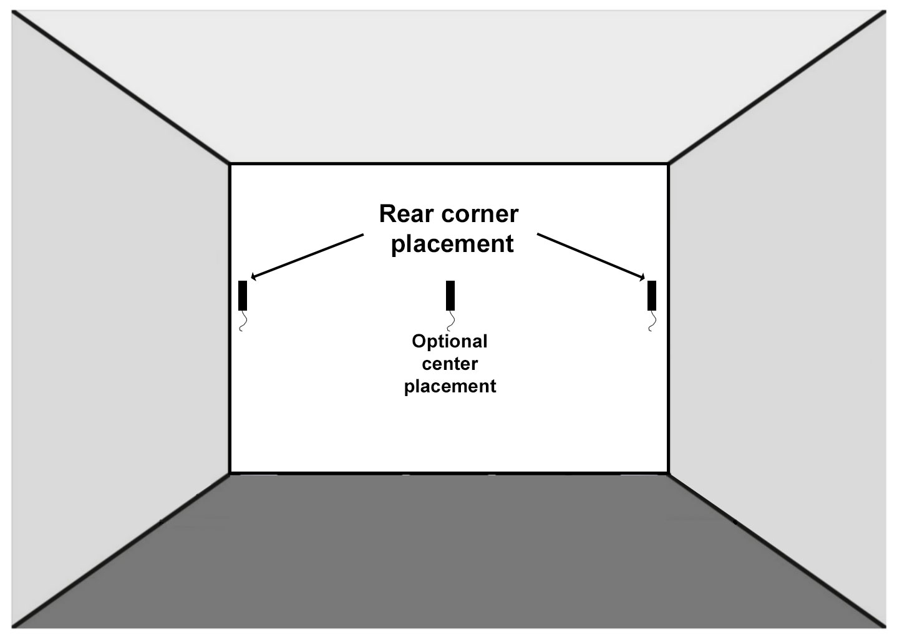
www.bybeetech.com

